Millerton Reservoir Temperature Monitoring Summary, 2012

Reservoir Temperature Profiles- One temperature profiling string was deployed to continuously monitor temperature stratification in Millerton Reservoir. The temperature string (TS) location is shown on figure 1 and is described as follows:

- Friant Forebay Temperature String – In the old river channel upstream from Friant Dam, a full depth string located near the Dam with 15 temperature loggers irregularly spaced to capture the detail in the epilimnion and metalimnion and to a lesser extent the hypolimnion.

String ID is MLSTRNG, Forebay Temp String at GPS coordinates N37.00553°, W119.69492°

Manual Water Quality Profiles - Monthly or bi-monthly manual water quality profiles are collected by Friant staff at Forebay, Winchell Bay, and Finegold sites. These manual profiles can be used to calibrate reservoir temperature models and identify any errors in the temperature profile data.

Water Quality Sonde Calibration - Friant Dam staff follow the manufacturer’s calibration recommendations for In-Situ Troll 9500 (purchased August 2007). Calibrations are the responsibility of Friant Dam staff.

Inflow and Outflow Temperatures – Hourly outflow temperatures are monitored at the three major release points from Friant Dam (see figure 1) and from the fish hatchery and worm farm. They are as described as follows:

- River outlet works (San Joaquin River): TWTemp N36.99930°, W119.70597°, TW Water quality data is now available on CDEC’s website: http://cdec.water.ca.gov/cgi-progs/queryF?s=sjf
- Friant-Kern Canal: FKCANAL, N36.99697°, W119.70453°
- Madera Canal : MCTemp, N37.00220°, W119.70769°
- Main Outflow From Fish Hatchery/Worm Farm WF1 at N36.98485°, W119.72133°
- Secondary outflow from Worm Farm :WF2 at N36.98563°, W119.72028°

Fish Hatchery number is 559 822-2374

Worm farm owner is John Weigand and his telephone numbers are 559-284-3800 (cellular) and 559-434-9418 (home/office).

Millerton Lake Inflow temperature - Hourly inflow temperatures are collected in the Kerckhoff No. 2 powerplant and tailrace. Logger just below Kerckhoff #2 PP: HW at N37 04 13.6 W119 33 35.9
Added temperature loggers in the Kerckhoff #2 PP to directly measure release temperatures because the headwater temperature probe was measuring reservoir water at low or no flow for the powerplant.

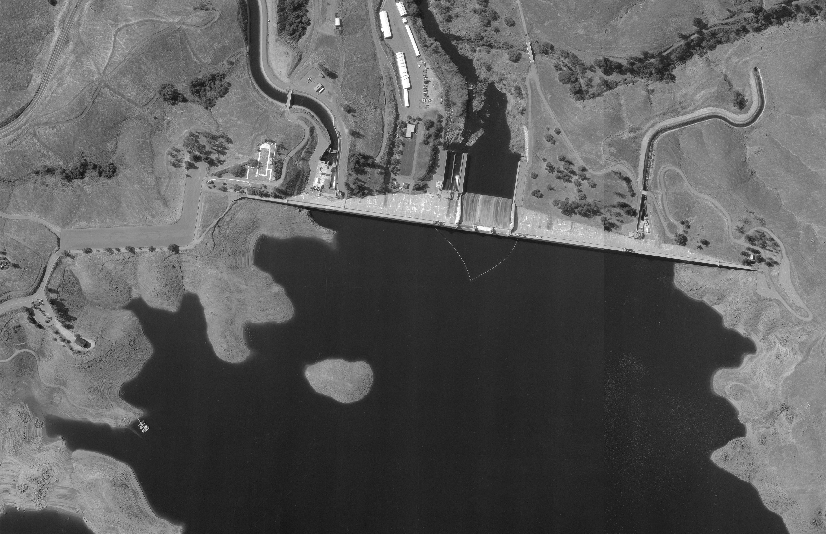
Continuous
Temperature
Profiling String
Madera Canal
Release Temp.
Friant-Kern Canal
Release Temp.
SJ River
Release Temp.
Weather Station
At existing CDEC
site (FRT)
Sites not shown: Kerckoff Powerplant and Fish Hatchery Release Temperatures
Temperature Monitoring and Weather Station Locations near Friant Dam.
Figure 1. Aerial photograph of Friant Dam and locations for temperature monitoring and weather station.

Files copied to the Sharepoint Site:

Friant ALL AGPM.xlsx -contains daily Friant Dam forebay temperature profile data from 2004 to present. This file also contains photos, metadata, and temperature contour graphs for years 2005-2012.

Finegold ALL AGPM.xlsx –contains daily Finegold bay temperature profile data from 2005 to present. This file also contains photos, metadata, and temperature contour graphs for years 2005-2009. Site abandoned when temperature string was lost.

FBELEV380.TECPLOT.xlsx –contains a daily water temperature record at River Outlet Intake Elevation 380 from 2005 to present. This file also contains a time-series temperature graphs for years 2005-2012.

FKCANAL Temps.xlsx -contains hourly water temperature record for water delivered to Friant-Kern Canal, 20045 to present.

MCANAL Temps.xlsx -contains hourly water temperature record for water delivered to Madera Canal, 2004 to present.

WORM FARM Temps.xlsx contains hourly water temperature record for Worm Farm return flows to San Joaquin River, 2004 to present.

TAILWATER Temps.xlsx - contains hourly water temperature record for water delivered to San Joaquin River below Friant Dam, 2004 to present.

HEADWATER Temps.xlsx - contains hourly water temperature record for water released from Kerckhoff PP No. 2 to the headwaters of Millerton Reservoir, 2004 to Nov 2012.
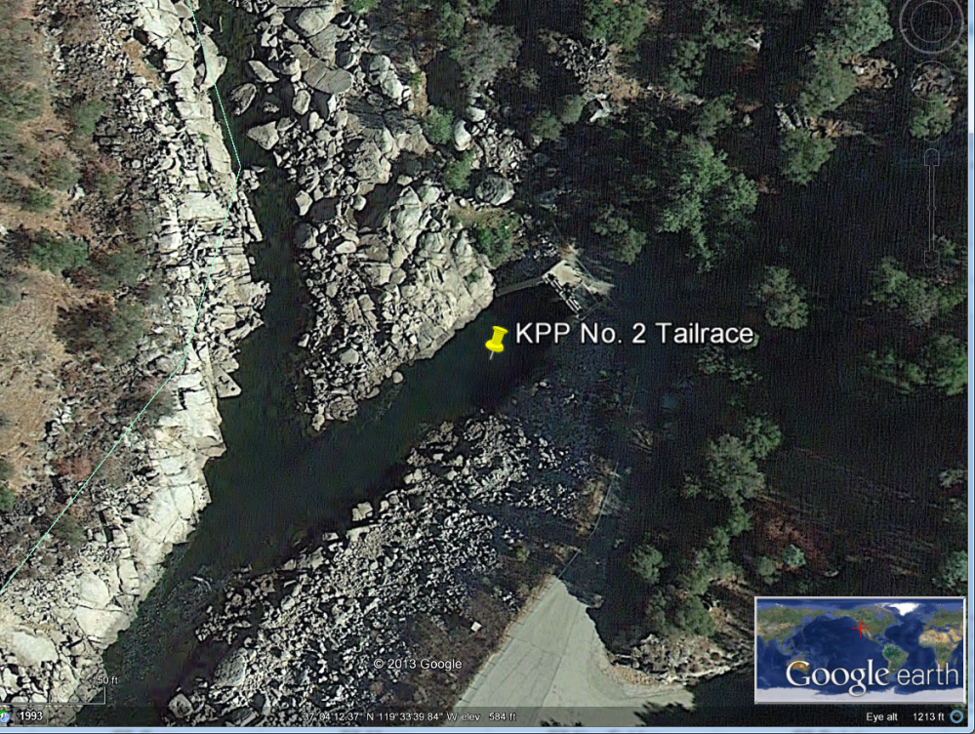
MILLERTON WQ PROFILES.xlsx – contains Summary of monthly water quality profiles collected at Friant Dam, Winchell Cove, and Finegold Bay.

Millerton WQ.sum.zip – contains XLS files for each water quality profile collected in Millerton Reservoir from 2003 to present.

Technical Service Center Contact is :

Tracy B. Vermeyen, P.E.
Hydraulic Engineer
U.S. Bureau of Reclamation
Water Resources Research Laboratory
P.O. Box 25007, D-8560
Denver, Colorado 80225-0007

Phone: 303-445-2154
FAX : 720-544-0551
Cell: 303-870-9178
e-mail: tvermeyen@do.usbr.gov

