Kimberlina Road Groundwater Recharge and Banking

The Kimberlina Road Groundwater Recharge and Banking (Project) would add a 60 cubic feet per second groundwater banking facility within Shafter-Wasco Irrigation District (ID) that can receive deliveries from the Friant-Kern Canal and the Calloway Canal. The Project will take delivery from two existing turnouts on the Friant-Kern Canal and will take advantage of five regional conveyance improvements that were recently constructed allowing delivery of water from the California Aqueduct to the new banking facility located off the Calloway Canal at Kimberlina Road. Three wells will be constructed adjacent to the spreading facility to recover the banked supplies. Refer to Figure 1 for the location of the banking facility and the routing of supply from the California Aqueduct to the banking facility.
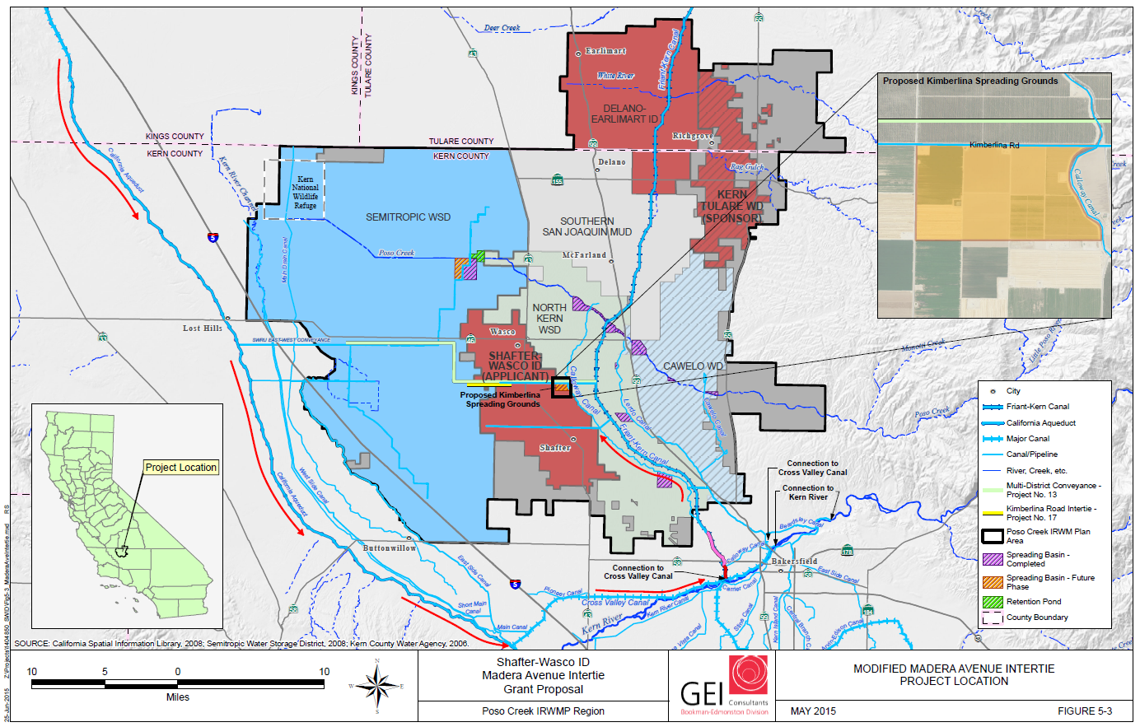
Figure 1. Project Site Map
The Project has an estimated total cost of $11,900,000, with a Federal cost share funding of $4,200,000.
The Project is estimated to provide 153,000 acre-feet of Recovered Water Account (RWA) reduction over the 30-year Project life cycle for Shafter-Wasco ID and Kern-Tulare Water District (WD), a participating Friant Contractor. Shafter-Wasco ID and Kern-Tulare WD will reduce RWA by 1) increasing deliveries of recirculated Restoration Flows from San Luis Reservoir, and 2) increasing deliveries of RWA water from Millerton Reservoir.

