Cordeniz Basin Groundwater Storage Project – Conjunctive Exchange Program

The Tulare Irrigation District (TID) is proposing to create a Conjunctive Exchange Program that addresses the loss of water supplies to the San Joaquin River Restoration Program by augmenting its groundwater recharge facilities to expand the use of wet year water in the Friant Division. The exchange program is based on the construction of the 80-acre Cordeniz Recharge Basin and the creation of a Water Exchange Purchase Fund to allow TID to purchase and recharge wet year supplies for subsequent return to exchange partners in dry years using TID’s Millerton Class 1 supplies. The Cordeniz Recharge Basin will include the creation of two individual basin cells that will be served by Serpa Ditch. The project site plan is shown in Figure 1.
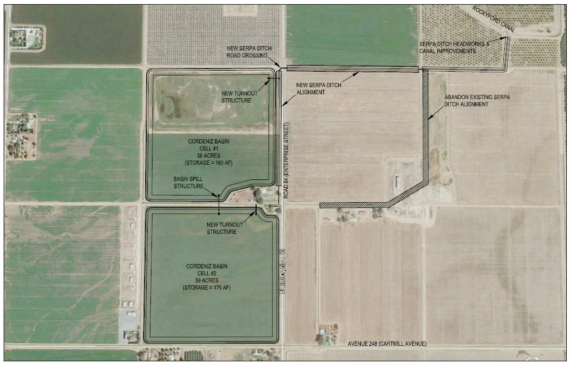
Figure 1. Project Site Map
The Project has a total estimated cost of $3,900,000 which includes the construction costs for the Cordeniz Basin as well as the funding of the Water Exchange Purchase Fund. The Federal cost share for this project is $1,950,000.
The total anticipated RWA reduction from the Project is 129,000 AF. This is based on 45,000 acre-feet (AF) of RWA reduction for TID (1,500 AF per year over the 30-year life of the Project) and 84,000 AF (2,800 AF over 30 years) from participating Friant Contractors that are required to reduce RWA balances equal to the amount of water returned through the exchange program.

