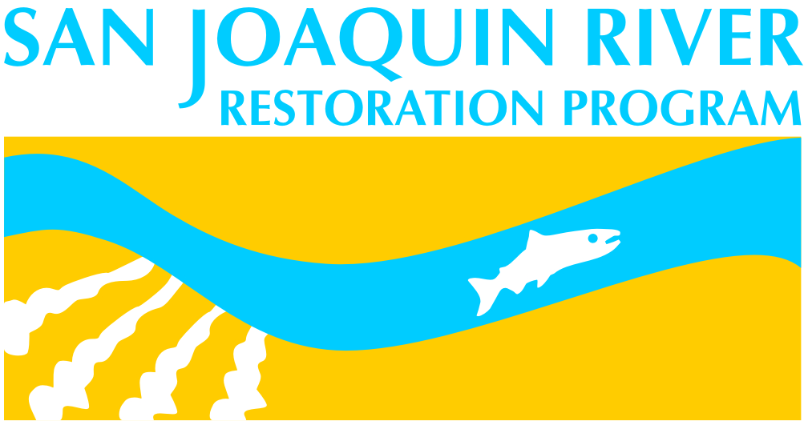 |  | San Joaquin River Restoration Program Science Meeting  Abstract Submission Form - 2016
General Information
Presentation Title:
Presenter: |  |  | Affiliation:
Phone Number: |  |  | Email Address:
Collaborating Authors, with affiliation:

Oral Presentation Poster Presentation Oral or Poster Presentation (Oral presentation if time available)
For MAP Studies, list study number:
Themes (select one)
. | Theme 1: Multi-benefit projects on floodplains: incorporating ecological and economic benefits  Theme 2: Adult Chinook salmon monitoring and migration  Theme 3: Hatchery operations, genetics, and broodstock selection to reintroduce an extirpated species  Theme 4: Spawning and incubation habitat for Chinook salmon  Theme 5: Production, survival, and movement of juvenile Chinook salmon in a newly wetted river: Addressing information needs for river restoration  Theme 6: Physical processes affecting river restoration: erosion, subsidence, groundwater, climate, watershed management, and more
Abstract (500 words or less)

